Q1

#include <stdio.h>

#include <string.h>

#include <stdlib.h>

#include <stdbool.h>

#include <unistd.h>

#include <fcntl.h>

#include <sys/types.h>

#include <sys/stat.h>

int main(int argc, char const *argv[])

{

if (argc != 2)

{

printf(" USAGE: filename pattern \n");

return 0;

}

// Prereqs

char ch;

char buffer[100];

int in, out;

in = open("input.txt", O_RDONLY);

out = open("output.txt", O_WRONLY);

// int line_no = 0;

int pattern_length = strlen(argv[1]);

int i = 0;

bool flag = false;

char end_line = '\n';

while (read(in, &ch, 1) == 1)

{

// printf(" %d", i);

if (ch == '\n')

{

// line_no++;

if (flag == true)

write(out, buffer, strlen(buffer));

write(out, &end_line, 1);

i = 0;

flag = false;

memset(buffer, '\0', sizeof(buffer));

}

else

{

buffer[i] = ch;

if ((i >= pattern_length) && (strcmp(argv[1], buffer + strlen(buffer) - pattern_length) == 0))

flag = true;

i++;

}

}

write(out, buffer, strlen(buffer));

return 0;

}

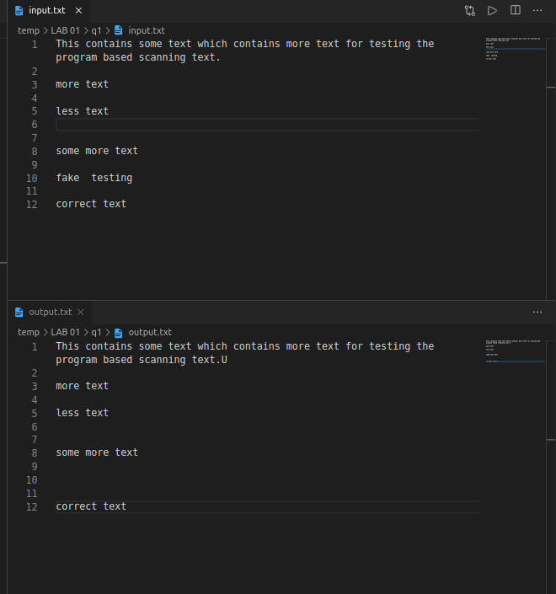

Q2

#include <stdio.h>

#include <string.h>

#include <stdlib.h>

#include <stdbool.h>

#include <unistd.h>

#include <fcntl.h>

#include <sys/types.h>

#include <sys/stat.h>

int main(int argc, char const *argv[])

{

if (argc != 2)

{

printf(" USAGE: filename pattern \n");

return 0;

}

// Prereqs

char ch;

char buffer[100];

int line_no = 0;

int in = open(argv[1], O_RDONLY);

while (read(in, &ch, 1) == 1)

{

if (ch == '\n')

line_no++;

printf("%c", ch);

if (line_no == 20)

{

while (read(0, &ch, 1) != 1)

;

line_no = 0;

}

}

return 0;

}

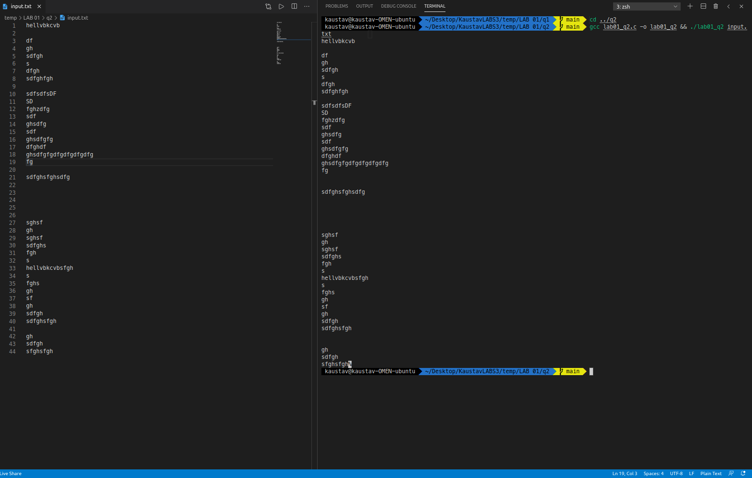

Q3

#include <stdio.h>

int main(int argc, char const *argv[])

{

char c = 'a';

printf("%c\n", c);

int i = 14;

printf("%d\n", i);

long int li = 18;

long long int lli = 501ll;

printf("%ld\n", li);

printf("%lld\n", lli);

unsigned long int ui = 10u;

unsigned long long int ulli = 10ull;

printf("%lu\n", ui);

printf("%llu\n", ulli);

float f = 12.30f;

double d = 3.1415;

printf("%f\n", f);

printf("%f\n", d);

long double ld = 3.5;

printf("%Lf\n", ld);

return 0;

}

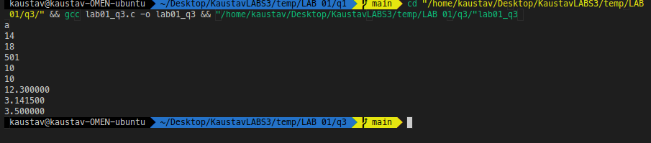

Q4

#include <stdio.h>

#include <stdlib.h>

#include <unistd.h>

#include <fcntl.h>

#include <sys/stat.h>

#include <sys/types.h>

int main(int argc, char const *argv[])

{

char c;

int in, out;

in = open("file.in", O_RDONLY);

out = open("file.out", O_WRONLY, O_CREAT, S_IRUSR | S_IWUSR);

while (read(in, &c, 1) == 1)

write(out, &c, 1);

exit(0);

}

